CHAPTER 1

BASICS OF VB Scripting

Differences between Programming Languages and Scripting Languages

PROGRAMMING LANGUAGES SCRIPTING LANGUAGES
1) It is used to build end-to-end application 1) It is used for end-to-end testing of an
application. Also used to develop a small
component of a bigger application

2) A program will undergo 1st compilation and 2) A script does line-by-line execution
then execution. or command interpretation.

3) Output of a programming language is called 3) Output of a scripting language is called
a program. a script.

4) Programming language is very complex to 4) Scripting language is very easy to understand
understand & implement & as a result it will & implement & we can learn it in a quick time
take more time.

5) Examples include – C, C++, Java, VC++ 5) Examples include – VBS, JavaScript, PHP,
PerlScript, ShellScript, Ruby

QTP supports both VB Scripting and Java scripting.
VB Scripting is very easy to learn and understand over Java Scripting/
The s/w vendor for QTP is HP.

We write VBS files in Notepad. The VBS files will have an extension .vbs
The Javascript files will have an extension .js
The VBS engine (s/w) is being in-built within the Windows OS itself and hence no additional s/w is required to execute the same.
VBS is one of the modules extracted from Visual Basic.

Let us see now how to write a VB script and save it and also the icon we must expect to see after we save the file.
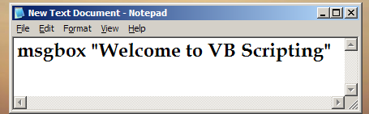
Shown above is a sample VB Script typed in Notepad.
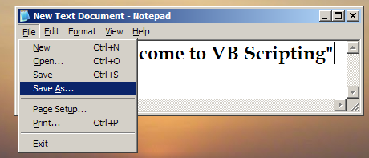

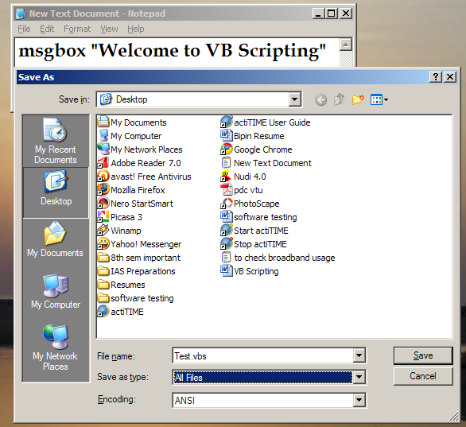

After typing the script in Notepad – we go to File and click on “Save As” – later we go to File name and give the name of the script along with .vbs extension – in the above example, we have stored it as “Test.vbs” and also in Save as type – we give it as “All Files”.
Once we have saved it, we see an icon as shown below on the desktop which is the file Test.vbs
Also, the output for the above is displayed as shown below,
 Icon 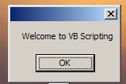 Output

msgbox
Similar to printf in C. This is a function which displays the message from the program to the user.

Ex:- msgbox “Welcome to VBS”

VBS is not case sensitive i.e, the commands are not case sensitive. The string values that have to be enclosed in the double quotes and the text within it are case sensitive.
Let us see the 2 examples shown below,

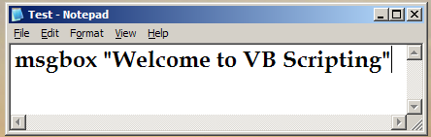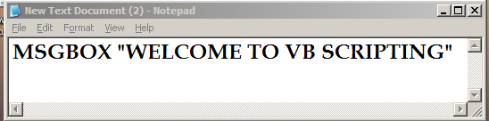

We’ll see the output for the above two inputs,
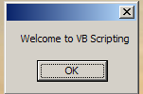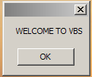

Thus, we can see that commands are not case sensitive, but the strings within the double quotes are case sensitive.

inputbox
This is similar to scanf in C.
It sends the input value from the user to the program / script.
Ex:- var = inputbox (“enter a value”)
msgbox var
msgbox “var”

The output we get for the above two are as shown below,
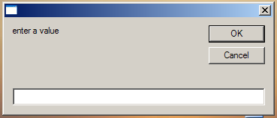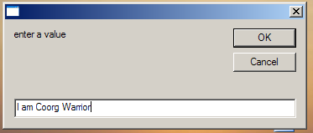
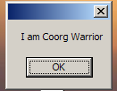 Output 1 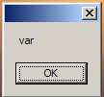 Output 2
When we type the above program using the command inputbox. We get the above – we enter the value and when we give OK – we get the entered string as output.
Thus from the above 2 outputs, we can conclude that – anything enclosed within double quotes accompanied by the command msgbox, it is accepted as a string.

var – it is a variable to store the value.
msgbox var – it gives the value of the variable.
msgbox “var” – it displays the string var.

To display the value of a variable, don’t use double quotes (“ “).
To display the string, always use double quotes.

CHAPTER 2
VARIABLES & DATATYPES

VARIABLE – A variable is a placeholder / container which stores some value in it. A variable can take different values at different points in time.

Rules for naming the variables
- A variable name should start with an alphabet
- A variable name should not exceed 255 characters
- A variable name cannot have any special characters except for underscore ( _ )
- The variable name should not be VB Scripting keyword / reserved word

Given below are some examples of valid & invalid variable names,
Invalid variable names,
Ex - 1name - cannot begin with a number. Always must begin with an alphabet
my name - no special characters allowed (blank space)
msgbox - cannot use a VB script keyword as a variable name

Valid variable names,
Ex - v123456789
my_name
magbox

Declaration of a variable
A variable is generally declared before it usage.
Dim – it is keyword to declare a variable. Dim stands for dimension.

Types of Declaration
- Implicit declaration
- Explicit declaration

Implicit Declaration
Here, we need not declare any required variables explicitly. We have to just use them. VBS implicitly declares all such variables on behalf of us.
Ex - var1 = inputbox (“enter a value”)
msgbox var1
var2 = 100
msgbox var2

The output for var1 would be whatever value we enter and the output for var2 would be 100.

Explicit Declaration
Here, we will declare all the required variables using ‘dim’ keyword.
Ex- 1) Dim var1, var2
var1 = inputbox (“enter a value”)
msgbox var1
var2 = 100
msgbox var2

Ex – 2) Dim var1, var2 => declaration
var1 = 100 => assignment
var2 = 200 => assignment
msgbox var1 + var2

The output for Ex – 2) is,
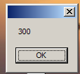

The declaration and the assignment cannot be done in the same line

Option Explicit
Now, from the above – we can see that there is not much of a difference between implicit and explicit declaration.
So, we use a keyword called option explicit.

Option explicit – it is a statement which makes all the variables required for the program have to be declared explicitly. It has to be provided at the beginning of the script.

Let us consider an example program shown below and see how option explicit is useful.

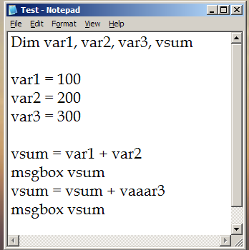 Script 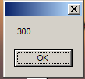 Output
In the above program, there is an error – although we are getting output – it’s the wrong output.
We can see that vaar3 is undefined – but, no error is shown and we get the output.
1st – vsum = var1 + var2 is evaluated and we get vsum = 100 + 200 = 300
Then, vsum = vsum + vaaar3 is evaluated – here, the compiler takes vaaar3 as 0 and hence we get vsum = 300 + 0 = 300. Thus, no error message is shown.

Now, let us see how option explicit can help us solve the above problem because in large programs, we cannot manually check for these errors – thus option explicit is used.

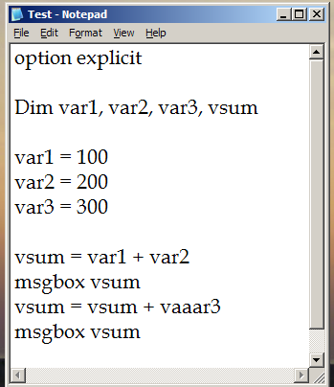 pgm1 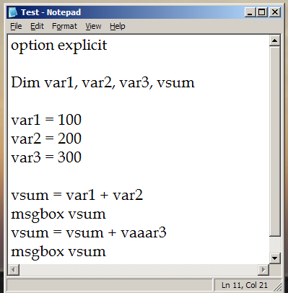

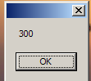 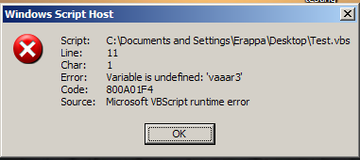 error message

We can see from above that – when we write the script using option explicit and run it – the 1st line vsum = var1 + var2 gets evaluated and the result 300 is displayed.
But, vsum = vsum + vaaar3 is not evaluated and we get an error message as shown above. It also displays in which line number(ln 11, col 21 – in the bottom right corner of the 2nd notepad) the error is present. We can check it and correct the error and we get the output as shown below,

As seen below(next page), we get the correct output 300 and 600.

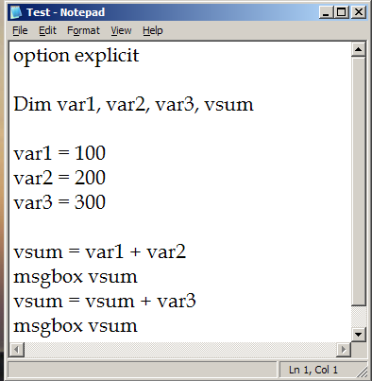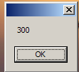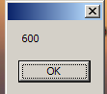

INTERVIEW TIPS
In Interview, when they ask you to write VB script programs – always follow the following 2 rules,
- Always write “Option explicit”
- Always write meaningful variable names like var vsum, vname etc – never use var a, var b, var c etc

CONSTANTS
A constant is a fixed variable i.e, its value never changes.
Constant’s value can never be changed during the course of the program. They are declared using the const keyword.
Consider the following examples along with their output shown below,
Ex – 1) const pi = 3.14

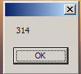 (Output of Ex – 2)
Ex – 2) const pi = 3.14
var = 100 * pi
msgbox var

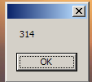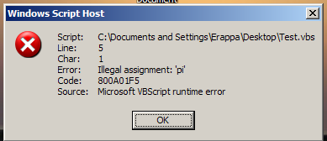
Ex – 3) const pi = 3.14
var = 100 * pi
msgbox var

pi = 900 => error

In ex – 3) – it first returns the value 314 and then returns an error for pi = 900.
Ex – 4) const pi
pi = 3.14

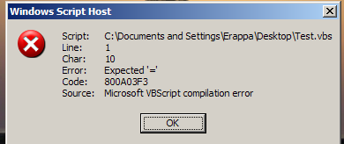

The above program – Ex - 4) – returns an error because pi has to be initialized.

Write a script to compute the area of circle. Make use of pi constant in the program. Also accept the radius from the user.

option explicit

Dim radius, area
const pi = 3.14

radius = inputbox ("enter the radius of the circle")
msgbox radius
area = pi * radius * radius
msgbox area

The output for the above program is given below,
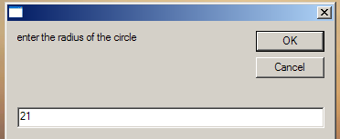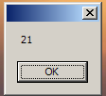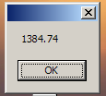

The above program will first accept the radius of the circle – then it will display the radius entered – and then it will calculate the area of the circle and will display the area of the circle.

DATATYPES
The only datatype available in VB scripting is variant.
A variable in VBS can take different types of values
A variant has many subtypes. The subtype of a variable can be identified based on the value stored in it.
Ex - var = 100
msgbox var - here the datatype of var is variant and the subtype is integer
var = “vbs”
msgbox var - here the datatype of var is variant and the subtype is string

We cannot associate a variable to specific datatype. But a variable will always have a datatype and a subtype.

Typename
This function returns the subtype name of a given variable.

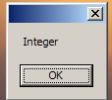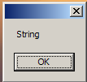
Ex - var = 100
msgbox var
msgbox typename(var)
var = “vbs”
msgbox var
msgbox typename(var)

In the above example – 100 is an integer and thus it displays integer – “vbs” is a string and thus it displays a string.
Thus, we can use typename to know the subtype of the variable.

List of subtypes

1) Empty – any variable not initialized.
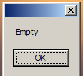
Dim var
msgbox typename (var)

2) Integer – any value between -32768 to +32767
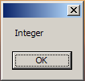
var = 32767
msgbox typename (var)

3) Long – any value apart from Integer range
var = 32768
msgbox typename (var)
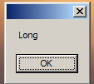

4) Double – any fractional values or decimal values.
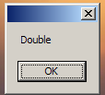
var = 3.345
msgbox typename (var)

5) String – any characters & special characters. The string should always be enclosed in “ “ (double quotes). Any inputbox value is always a string
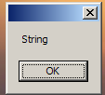
var = “VBS^$&*%#”
msgbox typename (var)

6) Boolean – True OR False
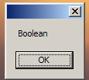
var = True
msgbox typename (var)

7) Date – any valid date and time. Should be within # #. 1 – Jan – 100 to 31 – Dec – 9999
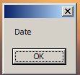
var = #2–Oct–1987#
msgbox typename (var)

8) Array – can store multiple values in a single variable at same point of time

9) Object – contains methods and properties

10) Err – for error handling

Write a script which accepts p, t, r from the user & compute the Simple Interest

option explicit

Dim principal, time, rate, SI

principal = inputbox ("enter the principal amount ")

time = inputbox ("enter the time")

rate = inputbox ("enter the rate of interest")

SI = (principal * time * rate)/100
msgbox SI

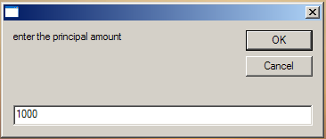

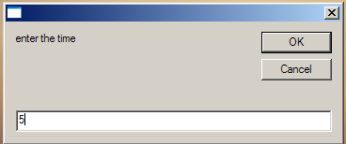

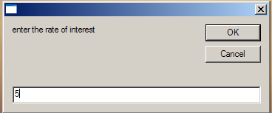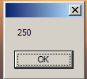

In the above example, it accepts principal amount, time, rate of interest and calculates Simple Interest.

Write a script which accepts two numbers and prints the sum and product of these numbers

Option explicit

Dim a, b, product

a = inputbox(“enter the first number”)
b = inputbox(“enter the second number”)

product = a*b
msgbox product

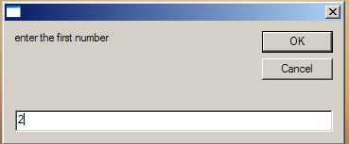

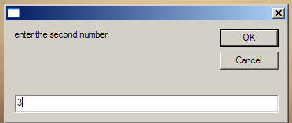
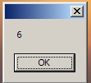

The above program takes two values ‘a’ and ‘b’ and prints the product of these two values.

DATE
Any date and time is given with Date subtype
The default display format is – MM / DD / YYYY
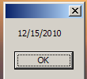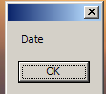
Ex – vdt = #15/12/2010#
msgbox vdt
msgbox typename (vdt )
Here, the 1st 2 digits will be taken as month. If they are not in the range of 1 – 12, then 2nd two digits will be considered as month & the 1st two as day/date.
In the above example, we can see the above – 15 is not in the month range, so it goes to DD field and 12 comes to MM field.

If both are out of range, then we get an error as shown below,
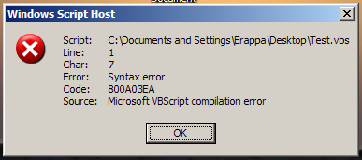
Ex – vdt = #15/15/2010#
msgbox vdt
msgbox typename (vdt )

We can pass the date in any format as shown below,
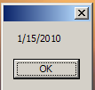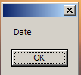
Ex – vdt = #15/Jan/2010#
msgbox vdt
msgbox typename (vdt )

Again in the above example, we can see that – Jan is converted to 1 in the MM field.

If we store a time in a variable, the subtype of it is also date itself.
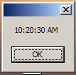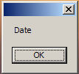
Ex – vdt = #10:20:30#
msgbox vdt
msgbox typename (vdt )

ARRAY
An array is a composite variable type which can store more than one value in it.

Ex – Dim varr (3)
In the above example, an array is defined with memory storage – 3. This is allocated in the memory as shown below,

QSPIDERS
300
TRUE
2.345678

In the above figure, we can see that declaring varr(3) has created 4 memory locations – 0, 1, 2, 3

CONVERSION FUNCTIONS
A conversion function is a function which converts a value from one subtype to another subtype.

The various conversion functions are,
- Cint – converts into integer
- Clng – converts into long
- Cdbl – converts into double
- Cstr – converts into string
- Cdate – converts into date
- Cbool – converts into Boolean

Now, let us see how using the above conversion functions helps in finding the sum of two numbers.
1st, let us consider sum of two numbers using normal functions.
Option explicit

Dim a, b, sum

a = inputbox(“enter the first number”)
b = inputbox(“enter the second number”)

sum = a + b
msgbox sum

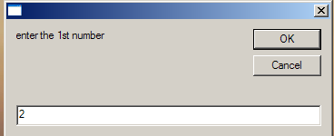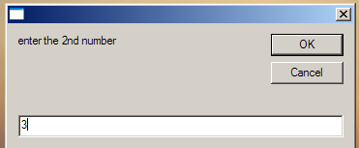

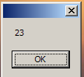
Using the above program, we can see that instead of adding two numbers, the sum function is concatenating the 2 numbers. This happens because – VBS accepts anything between double quotes as a string, so instead of adding up the 2numbers, it concatenates the 2 numbers.

Now, let us observe how we eliminate the above problem using conversion functions.

We write the program as shown below for finding the sum of two numbers,

option explicit
Dim vnum1, vnum2, vsum

vnum1 = cint (inputbox ("enter first number"))
vnum2 = cint (inputbox ("enter second number"))

vsum = vnum1 + vnum2
msgbox vsum

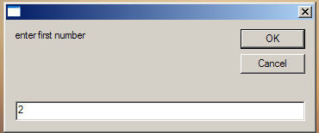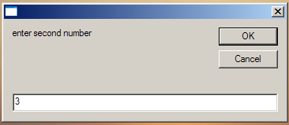

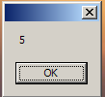 Thus, we get the sum of two numbers.
If we want to add numbers which are exceeding the range of integers, then we must convert it to long i.e, clng.

Cdate
This converts to date format
var = inputbox (“enter a date”)
msgbox vdt
msgbox cdate (vdt)

var = inputbox (“enter a value”)
msgbox typename (val)

vdt = cdate (val)
msgbox typename (vdt)

val = cstr (vdt)
msgbox typename (val)

The above program takes a string and converts it into date and then converts back to string

Cbool
1) val = -100
msgbox typename (val)

var = cbool
msgbox var
msgbox typename (var)

In the above example, we are seeing how to convert integer to Boolean type.
Here, zero is always false. Anything apart from zero will always be true, even 0.000000001 is also true.
We cannot convert a string to a bool. Only integer can be converted to bool.

CHAPTER 3
OPERATORS

Operators are classified into the following,
- Arithmetic operators
- Relational operators (Comparison operators)
- Logical operators
- Concatenation operators
- Comments

ARITHMETIC OPERATORS
- + - addition
- - - subtraction
- * - multiplication
- / - normal division
- \ - integer division
- Mod
- ^ - exponent

\ - integer division – it returns the integer portion of the quotient.
Let us see the difference b/w integer and normal division as shown below,
a = 10
b = 3
c = a/b
msgbox c
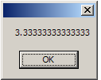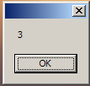
a = 10
b = 3
c = a\b
msgbox c
In normal division, it returns the remainder as well. But, in integer division, even if there is a remainder – it returns just the integer part of the quotient

Mod – it returns the remainder when the number is divided by the other.
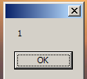 thus, we can see that it returns the remainder 1 when 10 is divided by 3.
a = 10
b = 3
c = a mod b
msgbox c
Exponent – denoted by ^ - returns the x to the power of y value.
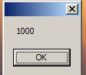 thus it returns 10³ = 1000
a = 10
b = 3
c = a ^ b
msgbox c
Precedence (or hierarchy) of Arithmetic operators
- Exponent
- Multiplication
- Normal division
- Integer division
- Mod
- Plus
- Minus

Ex: 10 + 34 * 2 – 10 ^ 3
10 + 34 * 2 – 1000
10 + 68 – 1000
78 – 1000
-922

( 10 + 34 ) * 2 – 10 ^ 3
44 * 2 – 1000
88 – 1000
- 912

Thus, we can see that using of brackets ( ) will override the default precedence and whatever is there in the brackets will be evaluated first.

We can use the above examples using VBS,
var = 10 + 34 * 2 – 10 ^ 3
msgbox var

var = ( 10 + 34 ) * 2 – 10 ^ 3
msgbox var

RELATIONAL OPERATORS
These operators return either true or false
- > - greater than
- < - lesser than
- < > - not equals
- > = - greater than or equal to
- < = - lesser than or equal to
- = - equals to
- Is

LOGICAL OPERATORS
- NOT
- AND
- OR

Logical Truth Tables

Truth table for AND
A | B | A and B
T | T | TRUE
T | F | FALSE
F | T | FALSE
F | F | FALSE

Truth table for OR
A | B | A or B
T | T | TRUE
T | F | TRUE
F | T | TRUE
F | F | FALSE

NOT (False) = True
NOT (True) = False

COMMENTS
A comment marks a line of code not to be executed by the VBS.
Comments help in understanding the code without actually writing it.
A comment can be provided with single quotes ( ‘ ) or REM.
There is no multi-level commenting facility in VBS.
For ex - ‘ Program to add two numbers
REM date : 25/03/2011

a = 10
b = 20
c = a + b
msgbox c ‘ displaying the output

CONCATENATION OPERATORS
These operators help us to concatenate (join) any two values.

We have two concatenation operators,

a) + - Plus – it concatenates any two given strings. When it is used for two numbers, it returns the sum of them instead of concatenating them.

For ex - a = “vbs”
b = “qtp”

c = a + “ – “ +b
msgbox c

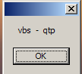

b) & - ampersand – it concatenates any two given values.

Note – though ‘+’ is a concatenation operator, it is recommended to use ‘&’ for all concatenation operations

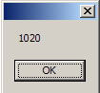
For ex - a = 10
b = 20

c = a & b
msgbox c

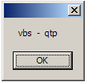
For ex - a = “ vbs ”
b = “ qtp “

c = a & “ – “ & b
msgbox c

For ex - ‘ln, fn
option explicit
dim vfn,vln,vstr

vfn = inputbox (“enter first name”)
vln = inputbox (“enter last name”)
vstr = vln & “ , “ &vfn
msgbox vstr

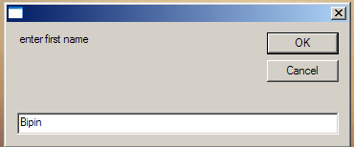

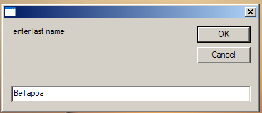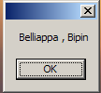
Write a VB script to accept 1st name, middle name and last name in separate input boxes and display the output as shown below,

Full name is : LN MN, FN.

' ln , fn

option explicit

dim vfn,vln,vmn,vstr
vfn = inputbox ( " enter first name " )
vln = inputbox ( " enter last name " )
vmn = inputbox ( " enter middle name " )
vstr = "Full name is " & " : " & vln & " " & vmn & " , " & vfn & " . ”
msgbox vstr

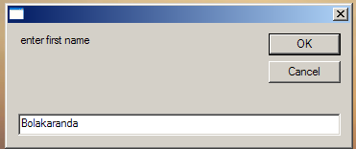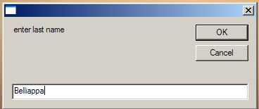
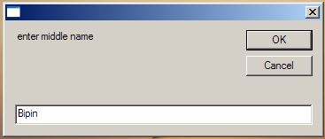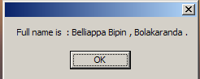

vbnewline – it adds a new line character between any two values.

For ex- 1) msgbox “ hi ” & vbnewline & “ hello “

2) msgbox “ hi “ & vbnewline & “ hello “ & vbnewline & “ bye “

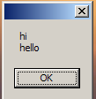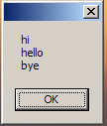

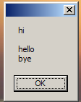
For ex- dim vstr
vstr = “ hi “ & vbnewline & vbnewline
vstr = vstr & “ hello “ & vbnewline
vstr = vstr & “ bye “

msgbox vstr

Write a VB script to accept first name, last name, age and date of birth of a user and display the output as shown below,

The details are :
LN, FN
Age
Date of birth

option explicit

dim vstr,vln,vfn,vage,vdate

vfn = inputbox ( " enter the first name " )
vln = inputbox ( " enter the last name " )
vage = inputbox ( " enter the age " )
vdate = inputbox ( " enter the date of birth " )

vstr = " The details are " & " : " & vbnewline
vstr = vstr & " " & " " & " " & " " & " " & vln & " , " & " " & vfn & vbnewline
vstr = vstr & " " & " " & " " & " " & " " & vage & vbnewline
vstr = vstr & " " & " " & " " & " " & " " & vdate
msgbox vstr

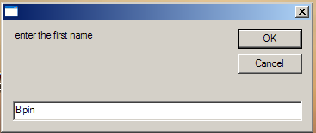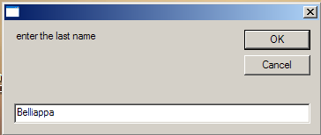
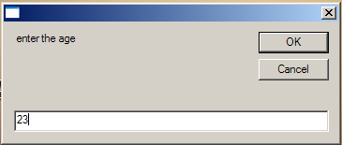
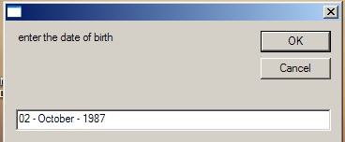
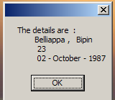

CHAPTER 4

CONTROL Statements

Different types of Control statements are,
1) IF statements
2) SELECT . . . CASE statements
3) Loops
- FOR . . . NEXT loop
- FOR EACH . . . NEXT loop
- Do . . . LOOP While
- Do While . . . loop
- Do . . . until WHILE
- Do UNTIL . . . loop
- WHILE . . . WEND

IF Statements
It is the basic form of decision control statements

Forms of IF statements

1) Simple IF statement
Generally these statements will not have any else statements.
For ex- vnum1 = cint ( inputbox ( “enter a number “ ) )
vnum2 = cint ( inputbox ( “enter a number “ ) )
if vnum1 > vnum2 then
msgbox vnum1 & “is greater “

end if

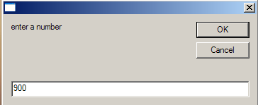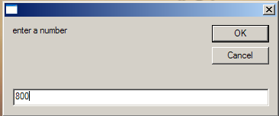

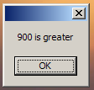

If the first number is not greater than the 2nd number in the above program, then no output is displayed. Only if the first number is greater – then output will be displayed

NOTE – The same code can be re-written without endif as shown below,
IF vnum1 > vnum2 then msgbox vnum1 & “is greater.

Endif is optional – if we have only 1 single line of executable code written in the same line as of “if” statement.

Write a VB script to accept a number and check whether it is an odd number

option explicit

dim vnum1, vdiv

vnum1 = cint ( inputbox ( " enter a number " ) )
vdiv = vnum1 mod 2
msgbox vdiv
if vdiv <> 0 then msgbox vnum1 & " is odd "

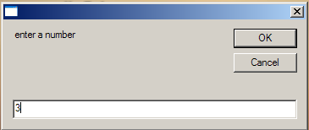
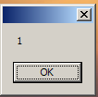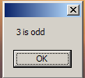

2)If … Else Statement

Let us consider the program to find the greatest of two numbers and see how we can use if else for this program,
option explicit

dim vnum1, vnum2

vnum1 = cint ( inputbox ( “enter a number “))
vnum2 = cint ( inputbox ( “enter a number “))

if ( vnum1 > vnum2 ) then
msgbox vnum1 & “ is greater ”
else
msgbox vnum2 & “ is greater “
end if

Let us consider the program to find the odd and even number and print if the number is odd or even
option explicit

dim vnum1, vdiv

vnum1 = cint ( inputbox ( " enter a number " ) )
vdiv = vnum1 mod 2
msgbox vdiv
if vdiv <> 0 then
msgbox vnum1 & " is odd "
else
msgbox vnum1 & “ is even “
end if

3) if …. Else if … else statements
Now, let us consider the program to find the greatest between two numbers or if the numbers are equal,
option explicit

dim vnum1, vnum2

vnum1 = cint ( inputbox ( “enter a number “))
vnum2 = cint ( inputbox ( “enter a number “))
(contd .. next page)

(contd from previous page .. )

if ( vnum1 > vnum2 ) then
msgbox vnum1 & “ is greater “
elseif ( vnum1 < vnum2 ) then
msgbox vnum2 & “ is greater “
else
msgbox “ both are equal “
end if

Program to accept three numbers and print the highest among them,
option explicit

dim vnum1, vnum2, vnum3

vnum1 = cint ( inputbox ( “enter a number “))
vnum2 = cint ( inputbox ( “enter a number “))
vnum3 = cint ( inputbox ( “enter a number “))

if ( vnum1 = vnum2 ) and ( vnum1 = vnum3 ) then
msgbox “ all are equal “
elseif ( vnum1 > = vnum2 ) and ( vnum1 > = vnum3 ) then
msgbox vnum1 & “ is greater “
else if ( vnum2 > = vnum1 ) and ( vnum2 > = vnum3 ) then
msgbox vnum2 & “ is greater “
else
msgbox vnum3 & “ is greater “
end if

Write a program to accept three numbers and print the least among them

Write a program to accept 4 numbers and print the highest among them

Note : endif is mandatory for if …else and if…else…if statements. One if should have only one endif.
Write a VB script to compute electricity billing amount with the help of following requirements,
a) number of units consumed should be entered
b) cost per unit is shown below,
1st 100 units – Rs 2 / unit
Next 100 units – Rs 4 / unit
Remaining is – Rs 6 / unit
c) any outstanding amount (arrears) should be entered
a fine of 3% on outstanding amount should be added

option explicit

dim vunit, varrears, vbill

vunit = cdbl(inputbox("enter the number of units consumed"))
varrears = cdbl(inputbox ("enter the arrears amount"))
if (vunit < 0) then
msgbox "invalid input"
elseif(vunit <= 100) then
vbill = vunit * 2
vbill = vbill + varrears + 0.03 * varrears
msgbox " The bill amount is " & vbill
elseif(vunit > 100) and (vunit <= 200) then
vbill = (100 * 2) + (vunit - 100) * 4
vbill = vbill + varrears + 0.03 * varrears
msgbox " the bill amount is " & vbill
else
vbill = (100 * 2) + (100 * 4) + ((vunit - 200)*6 )
vbill = vbill + varrears + 0.03 * varrears
msgbox " the bill amount is " & vbill
end if

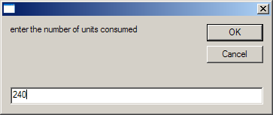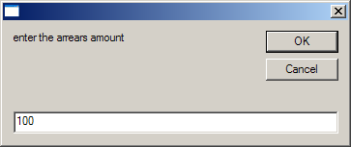
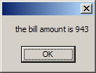
4) Nested if statements
- “ if ” within a “ if ”
- All the “ if “ statements should have corresponding endif statements unless it’s a simple if

Consider the program shown below – accept a number greater than zero and find if its even or odd. If its odd, then find if its divisible by 9 and print the result.
option explicit

dim vnum

vnum = cint ( inputbox ( “enter a number”) )

if vnum = 0 then
msgbox “ invalid “
else
if vnum mod 2 = 0 then
msgbox “ even “
else
msgbox “ odd “
if vnum mod 9 = 0 then
msgbox vnum & “ is divisible by 9 “
else
msgbox vnum & “ is not divisible by 9 :
end if
end if
end if

Program – accept two numbers and find out whether the 1st one is greater than the 2nd number. If the 1st one is greater, then accept another number and compare both of them
option explicit

dim vnum1, vnum2, vnum3

vnum1=cint(inputbox("enter the first number"))
vnum2=cint(inputbox("enter the second number"))

if(vnum1>vnum2) then
msgbox vnum1 & " - first number is greater"

vnum3=cint(inputbox("enter the third number"))

if (vnum1 > vnum3) then
msgbox vnum1 & " - first number is greater"
else
msgbox vnum3 & " - third number is greater"
end if
end if

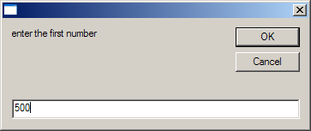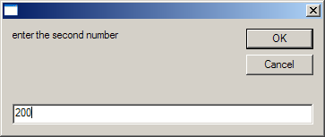
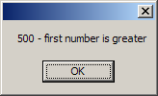
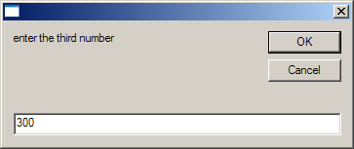

SELECT CASE Statements
It is like switch case statements in other languages. It is just like if statement, but much more flexible than if.
Whatever we write using if statements cannot be rewritten using select case statements except some of them.
But, whatever we write using select case statements, we can easily write using if .. else .. if statements
Select should always be ended with end select
If the if statements contains any other operator except equals, then we cannot rewrite with select case.

For ex, consider the program shown below,
option explicit

dim vchoice

vchoice = inputbox (“enter a choice ; 1 – cheque, 2 – cash, 3 – card”)

select case vchoice
case “1”
msgbox “ cheque number please “
case “2”
msgbox “cash please”
case “3”
msgbox “card number please”
case “4”
msgbox “invalid choice”

end select

Write a VB script to design a calculator application using select case
(refer next pg)

option explicit

dim vchoice,a,b,c,d,e

vchoice = inputbox("Enter a choice : 1 - addition, 2 - subtraction, 3 - multiplication, 4 - division, 5 - exponent, 6 - modulus, 7 - odd number or even number")

select case vchoice
case "1"
a = cint(inputbox("Enter the 1st number"))
b = cint(inputbox("Enter the 2nd number"))
c = a + b
msgbox "The sum is" & c

case "2"
a = cint(inputbox("Enter the 1st number"))
b = cint(inputbox("Enter the 2nd number"))
c = a - b
msgbox "The difference is" & c

case "3"
a = cint(inputbox("Enter the 1st number"))
b = cint(inputbox("Enter the 2nd number"))
c = a * b
msgbox "The product is" & c

case "4"
a = cint(inputbox("Enter the 1st number"))
b = cint(inputbox("Enter the 2nd number"))
c = a / b
msgbox "The division is" & c

case "5"
a = cint(inputbox("Enter the 1st number"))
b = cint(inputbox("Enter the 2nd number"))
c = a ^ b
msgbox "The exponent value is" & c

case "6"
a = cint(inputbox("Enter the 1st number"))
b = cint(inputbox("Enter the 2nd number"))
c = a mod b
msgbox "The remainder is" & c

case "7"
d = cint(inputbox("Enter the number"))
e = d mod 2
msgbox e
if e <> 0 then
msgbox d & "is odd"
else
msgbox d & "is even"
end if

end select

CHAPTER 5

LOOPS

Loops are used for repeated execution of a code.
A loop will have,
- Initialization
- Incrementing
- Exit condition

Any loop without a proper exit condition will lead into an infinite loop, which should be avoided.

Let us see the basic structure of a loop, as shown below,
msgbox “hi”

i = 1 ‘Initialization

loop ‘starting the loop
msgbox i
if i =10 then exit ‘terminating the condition

i = i+1 ‘incrementing
end loop ‘ending of the loop

msgbox “hello”

FOR loop
Display numbers from 1 to 10 using FOR loop

Initialization exit criteria incrementing

for i = 1 to 10 step 1
msgbox i
next

this displays all the numbers from 1 to 10

The FOR loop will have initialization, increment and the exit condition in the same line and that’s why it is the simplest of all the loops.
FOR loop can be used when we know exact number of executions to be performed. If we don’t know, then we have to make use of DO or WHILE loops.
We change the step values as shown below,

EX – for i = 1 to 10 step 3 - This displays 1,4,7,10 – in gaps of 3

for i = 1 to 10 step 2 - this displays 1,3,5,7,9

if we don’t provide ‘step’, then it defaults to 1

Ex – for i =1 to 5
msgbox i
next

We can also print the values in the reverse order by providing negative steps as shown below,

Ex - for i =5 to 1 step -1
msgbox i
next

This displays in the order – 5,4,3,2,1

We can print all the values in a single msgbox as shown below,
Dim i, vstr

for i = 5 to 1 step -1
vstr = vstr & i & vbnewline
next

msgbox vstr
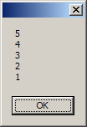

Write a script to print all the odd and even numbers in a separate msgbox (from 1 to 20)
option explicit
dim i,vstro,vstre

for i=1 to 20 step 1

if (i mod 2) <> 0 then
vstro = vstro & i & vbnewline
else
vstre = vstre & i & vbnewline
end if

next
msgbox "odd numbers : " & vbnewline & vstro
msgbox "even numbers : " & vbnewline & vstre

Write a VB script to print all the odd numbers between 100 to 200 in a single msgbox
option explicit

dim i,vstro

for i=100 to 200 step 1

if (i mod 2) <> 0 then
vstro = vstro & i & vbnewline
end if
next

msgbox "odd numbers : " & vbnewline & vstro

EXIT FOR
It is like ‘break’ statement in other languages
It terminates the loop intentionally without having to reach the upper boundary

Ex – Print 1st 5 odd numbers between 1 to 100
Option explicit

dim i,vcnt,vstro
vcnt = 0

for i = 1 to 100 step 2
vstro = vstro & i & vbnewline
vcnt = vcnt + 1

if vcnt = 5 then exit for
next
msgbox “ odd numbers “ & vbnewline & vstro

Display the 1st 20 even numbers between 400 to 300

option explicit

dim i,vstre

for i=400 to 300 step -1

if (i mod 2) = 0 then
vstre = vstre & i & vbnewline
end if
next
msgbox "even numbers between 300 and 400 in descending order : " & vbnewline & vstre

Write a script to print the factorial of a given number

option explicit

dim n,f,i

n=cint(inputbox("Enter the number"))

f=1

if n<0 then
msgbox "Invalid number"

elseif n=0 or n=1 then
msgbox "The factorial of the given number " & n & " is : " &f

else

for i=n to 2 step -1

f=f*i
next

msgbox "The factorial of given number" & n & " is : " &f

end if

Write a script to check whether a number is prime or not

option explicit

dim vf,vnum,i

vnum=cint(inputbox("Enter a number"))
if vnum = 0 or 1 then
msgbox "its composite number"
end if

for i=2 to vnum - 1

if (vnum mod i) = 0 then
vf="no"
exit for
else
vf="yes"
end if
next

if vf="no" then
msgbox "not a prime"
else
msgbox "its prime"
end if

Write a script to generate 1st 20 numbers in Fibonacci series
option explicit

option explicit

dim i, j, k, x, vstr, vnum

vnum = cint(inputbox("Enter how many numbers"))

i = 0
j = 1

vstr = i & " , " & j & " , "

'msgbox vstr

for x = 1 to vnum - 2

k = i + j
vstr = vstr & k & " , "
i = j
j = k
next
msgbox vstr

In the above program to find the Fibonacci numbers – if we want to find Fibonacci series for a series of specific numbers – we must change the ‘for’ statement from for x = 1 to vnum -2 to
for x = 1 to n (the specified number).

DO loops

Do loops are used when we don’t know the exact number of repetitions to be processed.

We have two forms of Do loops,

1) Do
……
……
While loop < condition >

Here, atleast once the loop is executed

2) Do while < condition >
…..
…..
Loop

Here, it may be 0,1 or many times. It checks the condition first. If the condition is false, then it will not enter the loop itself.

For ex, - use do loop to compute the factorial of a number and continue if needed for more executions

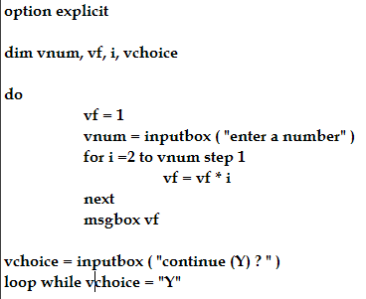

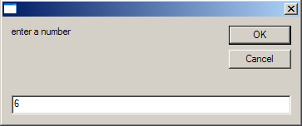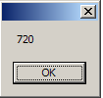

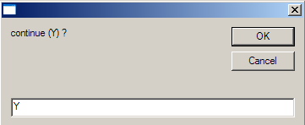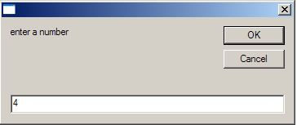

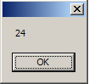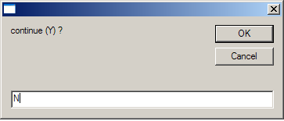

The control goes out of the loop.

Assignments
1) Modify the prime numbers program to continue for more than 1 execution

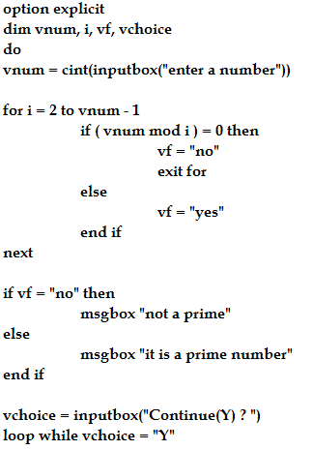

Example for do – while loop
Compute the factorial of a number

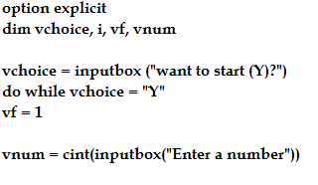
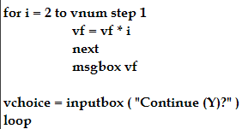

Assignment
1) Write a script to print 1 to 10 numbers using do – while in a single messagebox

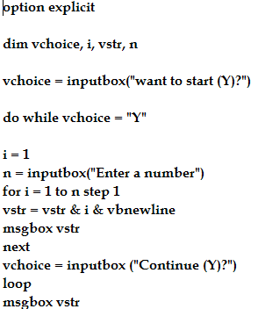

2) Write a script to print 1st 10 even numbers between 200 to 300 in a single messagebox using do – while loop

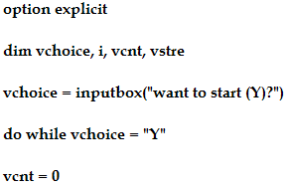

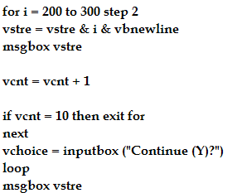

CHAPTER 6

ARRAYS

An array is a special subtype that contains multiple values of dis – similar type.

Advantages of array,
- It reduces the number of variables required for a program
- Using arrays, the program becomes much simpler & optimized (performance will be improved)
- It reduces the number of lines of code

Declaring an array
Ex - dim varr ( 4 )

Upper boundary of the array

Name of the array

Here, the size of the array is equal to (boundary + 1)

The array values can be declared via subscripts or an index.
The lowest subscript of an array in VBS is zero.

For ex,
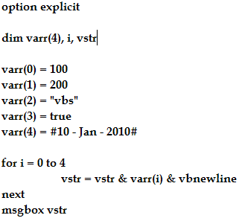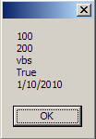

We can accept the values using FOR loop as shown below,

For i = 0 to 4
Varr (i) = inputbox ( “enter a value “ )
Next

Accept 5 numbers from an array and print the sum of them

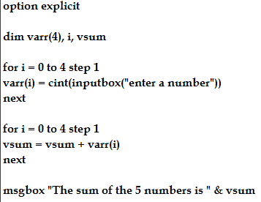

Accept 5 numbers from an array and print them in the reverse order

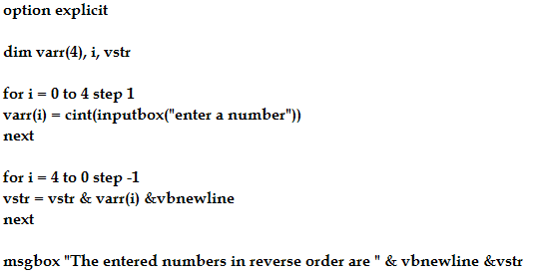

Accept 5 numbers and print the highest among them

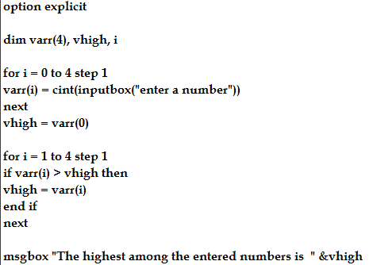

FOR EACH loop
It is the special type of FOR loop which is used only for arrays.
FOR EACH is used when we don’t know the upper boundary of the array.
FOR EACH can go to each and every element of an array and access the value in it (i.e, it checks each and every element from the 1st to the last).

For ex,
The following program accepts 5 numbers from an array and displays all the entered arrays in a single message box.

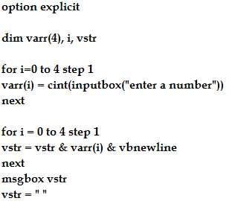

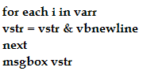

DIFFERENCES between FOR & FOR EACH

FOR loop | FOR EACH loop
1) To use FOR loop, we should know the upper boundary of the array  2) We can change the step values  3) We can selectively print the values  4) We can print the values in reverse order | 1) We need not know the upper boundary of the array  2) We cannot change the step values because it is always 1.  3) We cannot selectively print the values – its always from 0 to last  4) We cannot print the values in the reverse order.

To exit the FOR EACH loop in between, we have to use ‘exit for’ statement.
To exit the DO loop, we have to use the ‘exit do’ statement.

NESTED FOR loops
FOR loop within a FOR loop.

For each and every value of an outer loop, the entire inner loop will be executed.

For ex,
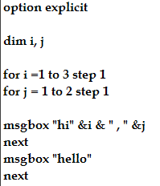

Display a picture as shown below,

*
* *
* * *
* * * *

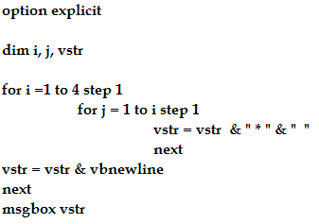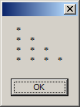

Display a picture as shown below,
* * * *
* * *
* *
*

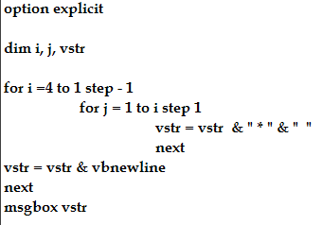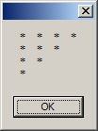

Display the picture shown below
1
1 1
1 1 1
1 1 1 1

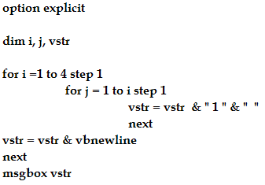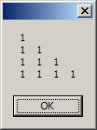

Display the picture shown below,
* * * *
* * * *
* * * *
* * * *

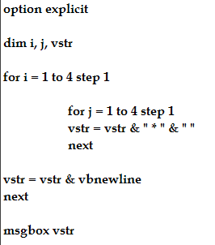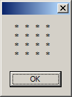

Display the picture as shown below
1
1 2
1 2 3
1 2 3 4

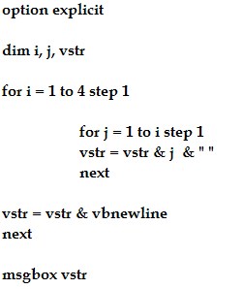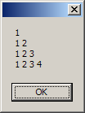

TYPES OF ARRAYS
1) Single Dimensional v/s Multi – dimensional arrays
2) Static v/s Dynamic

Single Dimensional Array
They are also called as 1 – D arrays
For ex, Dim varr (4)

Multi – Dimensional Array
They can be upto 2-d, 3-d, 4-d, 6-d etc upto 60-d etc.

For ex, Dim varr (2, 3)
Dim varr (3, 2, 1)
Dim varr (4, 5, 2, 3)

Note – In the real world, either we use 1-d or 2-d.

2 – d Arrays
It is used to generate matrix like data
It contains rows & columns
For ex, Dim varr (3, 2) means – 3 rows, 2 columns

Dim varr (3, 2)
100 (0, 0) | (0, 1) | (0, 2)
VBS (1, 0) | (1, 1) | (1, 2)
TRUE (2, 0) | 89.789 (2, 1) | (2, 2)
(3, 0) | (3, 1) | (3, 2)

For ex,
Shown below is a program to print a 2 * 2 matrix (2 rows, 2 columns)

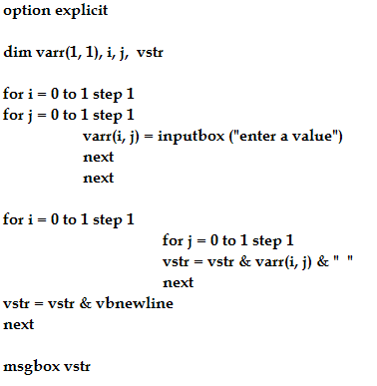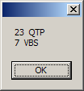

Program to print a matrix and also its transpose

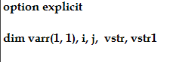

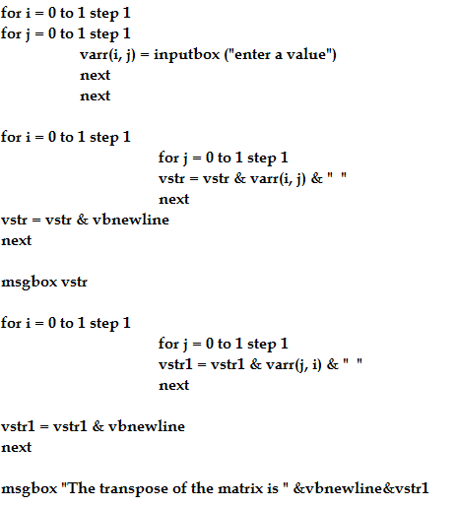

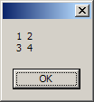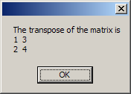

VB Script to add 2 matrices

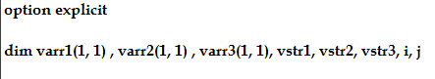

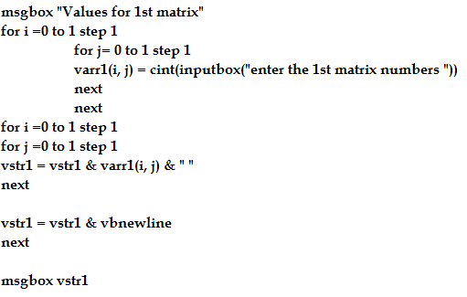
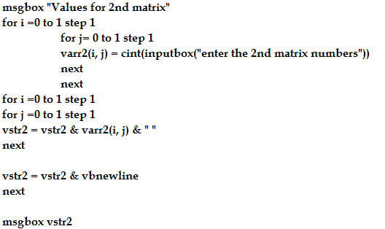

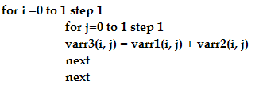
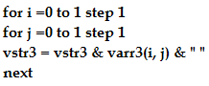

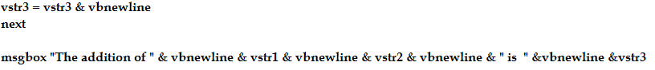

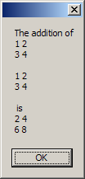

Static Arrays
They are also called as fixed arrays.
We cannot change the dimension of the array during the runtime.
For ex, Dim varr (3)

Dynamic Arrays
- These arrays can take different dimensions during the course of the program.
- They are helpful when we don’t know the exact dimension of the array.
- Sometimes, the upper boundary of the array will be unknown for sometime. In those cases also, we can make use of dynamic arrays.
- The same array can also be re – used by providing different upper boundaries within a same program.
- Dynamic arrays are created using redim keyword.

For ex,
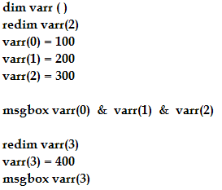

NOTE – When we redim an array, the previous values of the array will be erased. In order to preserve them, we have to redim an array with preserve keyword.

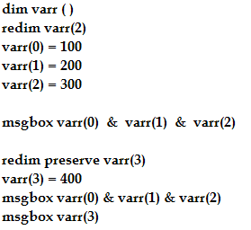

Note
Dim varr (4) - Single D & static
Dim varr (2, 4) – 2 –d & static
Redim varr(x) – single d & dynamic arrays

ARRAY FUNCTIONS

1) lbound – lower boundary – it is the lowest index / subscript of the array. It is always zero.
2) ubound – upper boundary – it returns the highest index of an array

For ex,

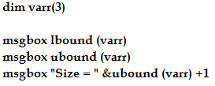

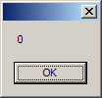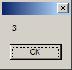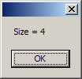

The above function returns – lower boundary which is always 0, upper boundary which is 3 as per the varr(3), and size of array which is 4(0, 1, 2, 3)

The for each can be replaced with for loop itself as shown below,
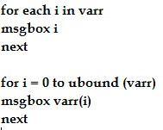

Accept ‘n’ numbers from the user & print the sum of them. Make use of ‘for each’ loop

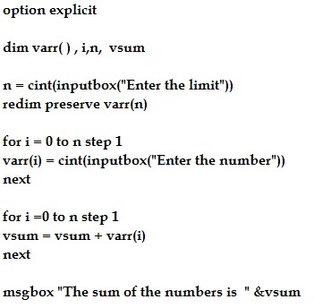

Write the same program shown above making use of ‘UBOUND’ in FOR loop

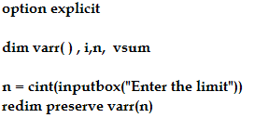
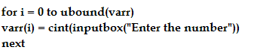

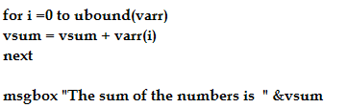

3) Split
This function splits the values of a given string based on a delimiter (also called as separator) and stores all the values in a single dimensional array.

For ex,
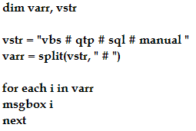

The above program prints vbs, qtp, sql , manual in separate message boxes.

If we don’t provide the delimiter, then it defaults to space.

We can provide any character as delimiter.

For ex,
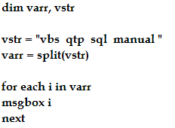

NOTE – if we want to print a string with double quotes, i.e for ex – if we want to print “vbs” – then we must use the code shown below,
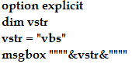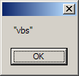
4) Join
It joins the values of an array with a given delimiter and forms a final string.

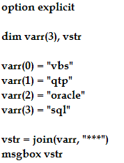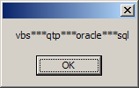

Accept some of the city names from the user. Also accept the delimiter from the user that separates each of the city names. Print each of the city names in separate message boxes using SPLIT function.

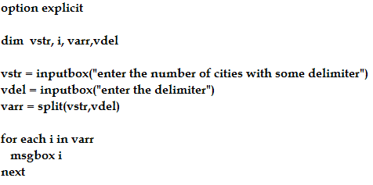

CHAPTER 7

FUNCTIONS & SUBROUTINES

These are the subprograms supported in VBS to write the modularized code.

Advantages
- Reusability of the code will be increased
- Debugging (chasing the bug) becomes much easier
- Helps in maintaining the modularized code

NOTE - Subroutines are also called as ‘subroutine procedure’ and functions are also called as ‘function procedures’

Differences between FUNCTION & SUBROUTINE

SUBROUTINE | FUNCTION
1) Subroutines will not return any value to the calling program  2) Subroutines – it cannot act like a function  3) A subroutine is created with a keyword called sub. | 1) Functions may/may not return any value to the calling program  2) Function – a function can act like a subroutine  3) A function is created with the keyword called function

CREATING A SUBROUTINE
For ex, write a script to create subroutine which computes the factorial of a number

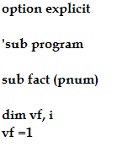
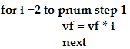
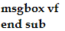
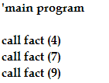

CREATING A FUNCTION
For ex, write a function to return the factorial of a number

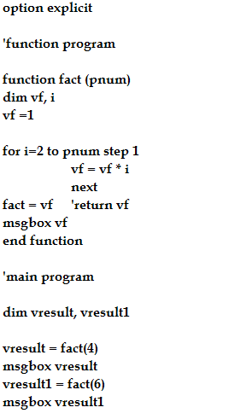

Write a function to compute Simple Interest

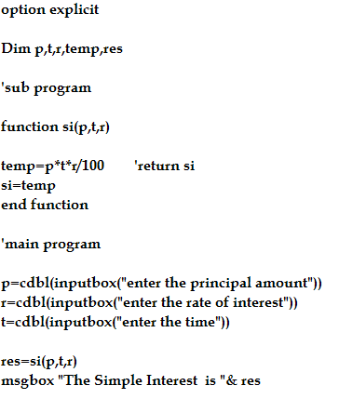

Write a function to check whether the number is prime or not

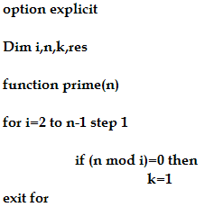
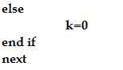

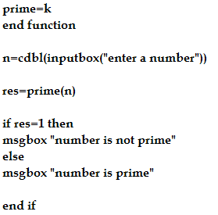

TYPES OF FUNCTIONS
- System Defined Functions ( Pre-defined functions )
- User Defined Functions ( Created by using FUNCTION keyword )

Pre – defined Functions are classified into,
- Character functions
- Numeric (math) functions
- Date functions
- Verification functions
- Conversion functions
- Array functions

CHARACTER functions
Lcase – Converts a string into lowercase
Ucase – converts a string into uppercase

For ex,

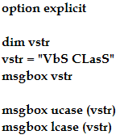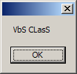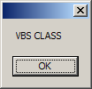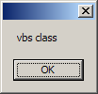

Len – returns the length of the given string.
For ex,

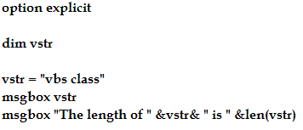
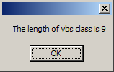

Accept a string and display a message if the string is not having atleast 5 characters

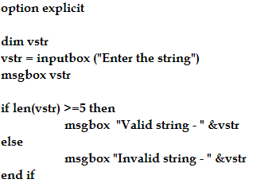

This is useful in testing field – we can find out length of the password and validate the password length. This is the real time application of finding the length of the string.

Left – it returns ‘n’ number of characters from the LHS of a given string
Right – it returns ‘n’ number of characters from the RHS of a given string
Mid – it extracts ‘n’ number of characters from the given position of a string

For ex, from the below example – we can see that,
1st output returns 4 characters from the LHS of the string
2nd output returns 5 characters from the RHS of the string
3rd output returns 3 characters from the 6th position from LHS of the string
4th output returns all the characters from the 6th position from LHS of the string
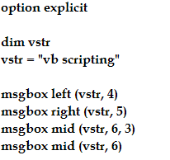

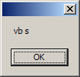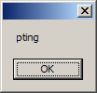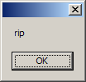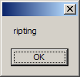

Ltrim – it trims of any blank spaces from the LHS of a string
Rtrim – it trims of any blank spaces from the RHS of a string
Trim – it trims from both LHS & RHS.

For ex,

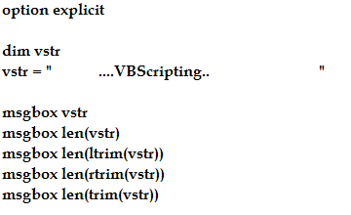
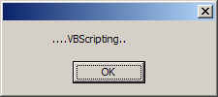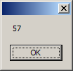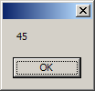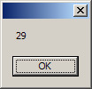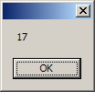
From the above program, we can see that it has trimmed of the blank spaces as per requirements and displays the length of the string after trimming.

Instr – it returns the position of given character in the given string.
For ex,

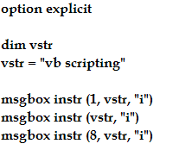

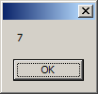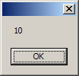

Accept a string and print whether letter ‘A’ is present in it.

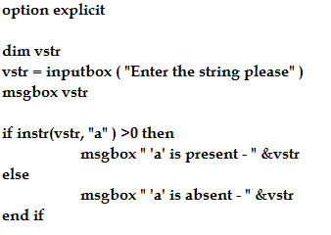

Accept 5 numbers & store in a array. Display highest among them

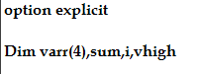

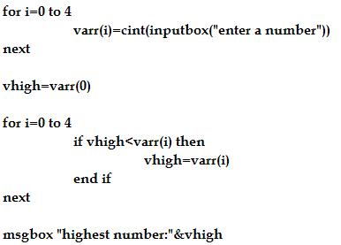

STRREVERSE
It reverses the given string
Ex,

Accept a string & check if it is a palindrome or not
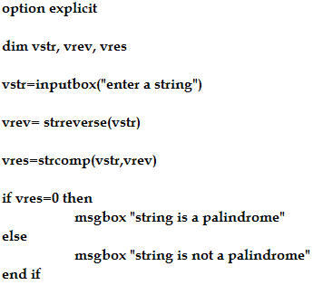

STRCOMP
It compares any 2 strings &
- returns 0 if both are same,
- returns 1 if str1 > str2,
- returns -1 if str1 < str2

Ex,
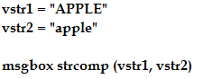
It returns -1 because ASCII values of lowercase is greater than Uppercase

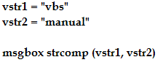
This returns 1 because v is greater than m

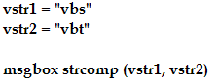
It returns -1 because t > s

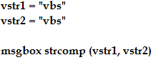
It returns 0

Accept 2 strings & print which is the greatest. If they are same, display the message accordingly
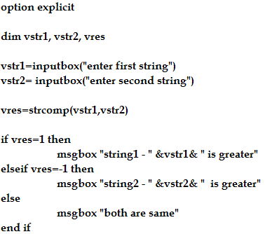

Accept 5 strings, store in a single dimensional array & print the highest among them
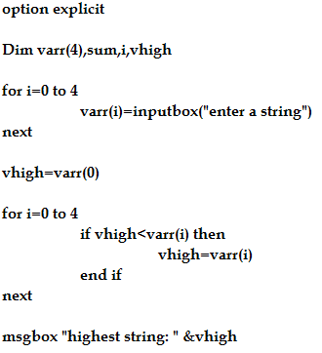

REPLACE
It replaces a old value from a new value in the given string

Ex,
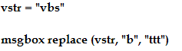

Replace can replace the blank space as well
Ex,
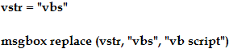

MATH FUNCTIONS
Sqr – returns the square root of the given number
Ex, msgbox sqr(100)

FSO – File System Objects
It is a default runtime object, which contains many methods, properties, variables & sub-objects in it.
A method is a function/subroutine stored in an object

VBS supports several objects to perform different kinds of real time requirements,
- FSO – contains methods related to File system
- EXCEL – contains methods related to perform excel related operations
- ERR – contains methods related to error handling

ARCHITECTURE of FSO
The FSO contains the following 3 sub – objects,
- Drive
- Folder
- File

CreateFolder DriveExists MoveFile
CreateTextFile FolderExists MoveFolder
CopyFolder FileExists
CopyFile

getDrive getFolder getFile openTextFile
DriveLetter  TotalSize  FreeSpace | Name  Size  DateCreated  DateLastModified  DateLastAccessed | Name  Size  Type  DateCreated  DateLastModified  DateLastAccessed | Read  ReadLine  ReadAll  AtEndoFStream  AtEndoFLine  Write  WriteLine  Close

Example to Create a Folder
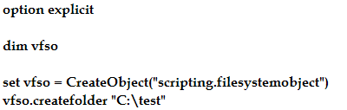

This creates a folder test in C drive

VB Script to check if a folder exists or not
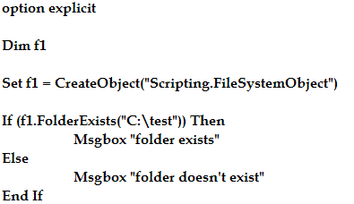

VB Script to copy a folder from 1 location to another location
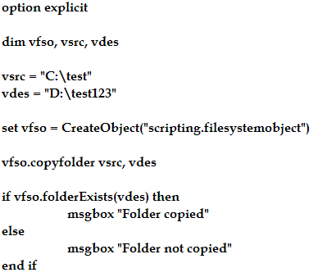

Accept a drive name (drive letter) & print the total size of it
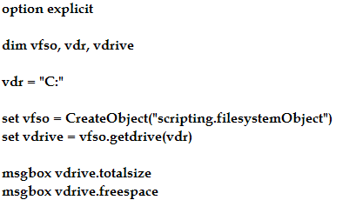
The above output file size is displayed in KB(s).
To display the drive size in GB,
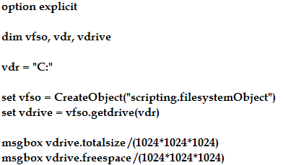

Accept a folder name & display the date of creation, its name & total size of it
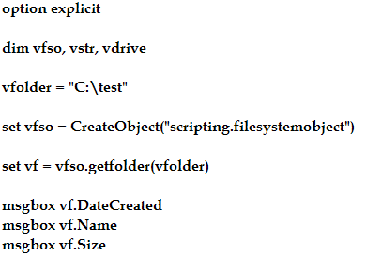

Program to rename a new folder
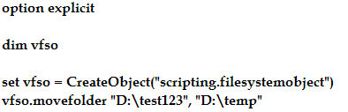

Program to display the drive name, free space & total size of it
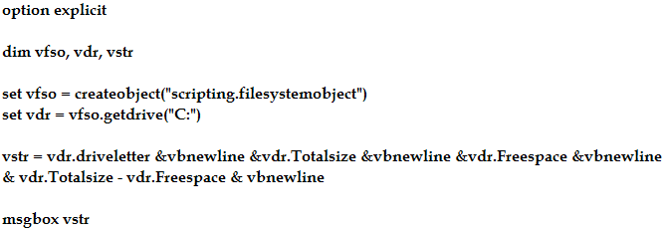

FILE INPUT / OUTPUT

AtEndofStream – it returns true when the end of the file is encountered during the read operation

AtEndofLine – it returns true when the end of the line is encountered during the read operation

File operations
- READ – internally represented by (1)
- WRITE – internally represented by (2)
- APPEND – internally represented by (8)

File processing Steps
- Open a file for a specific operation
- Perform the specific operations
- Close the file

VB Script to open a file & perform basic read operations
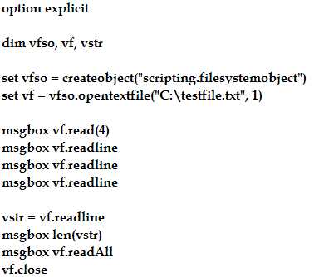
VB Script to read all the contents of a file & print each of the line in a separate msgbox
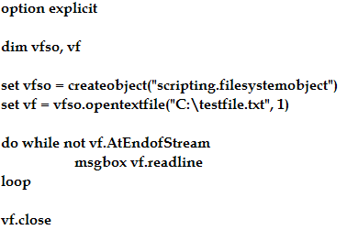

WRITE a script to enter some strings in a given file
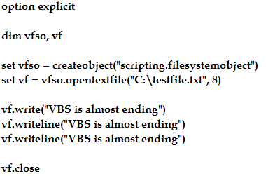

EXCEL Operations
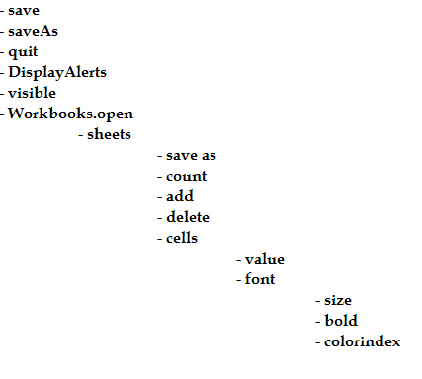

VB Script to perform basic read operations from an excel file

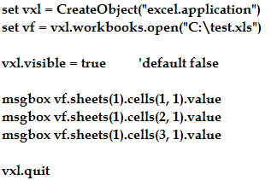

VB Script to perform basic write operations

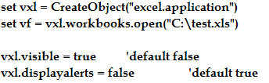

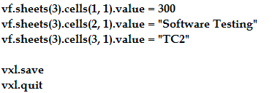

VB Script to set the font properties

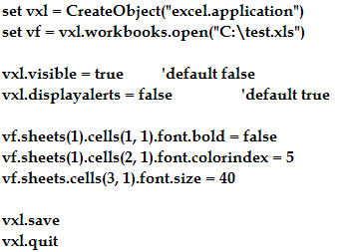

VB Script to generate all the color(s) between 1 to 56 in an Excel sheet

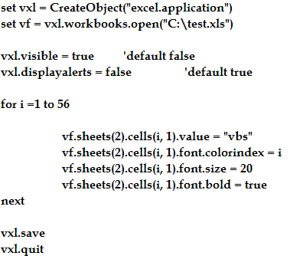

VB Script to copy from 1 excel sheet to another

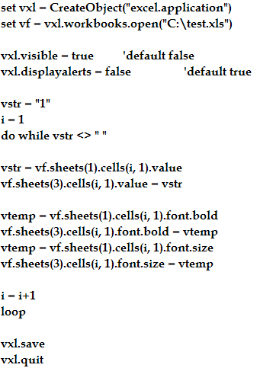

ERROR HANDLING

Error Handling is the process of trapping the VBS runtime errors & to facilitate the smooth execution

Error handling can be done,
- To make sure the control of the program goes to the last line of the code irrespective of any number of error coming on their way
- They are useful for capturing the system errors & displaying user defined messages

NOTE,
On error resume next – is used to initiate the error handling process
This should be given at the beginning of the script just after option explicit statement

Ex,
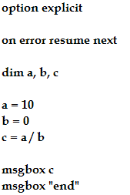

The ERR object
It is the default object which is used to capture the errors within a script

It has 2 methods in it,
- Err.number – it returns an unique error code / number for an error that is being raised within a script
- Err.description – it returns an error name for a given error code

Ex,
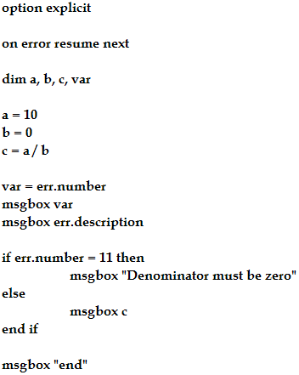

For a successful execution, the error code is zero & the error description is empty.

ASSIGNMENT PROGRAMS

1) Enhance program in PAGE 70 to check the existence of the given folder before creating it. If it exists - then dont create the folder & display a message that folder already exists.

2) Modify the program in Page 70 to allow the copy only if the source folder is existing

3) Write a script to rename a folder (make use of 'move folder')

4) Write a script to create a text file & print if it is successfully created or not
vfso.createtextfile "C:\temp.doc"

5) Write a script to display an output as show below for a given drive in a single msgbox,
Drive Name C
Total size X GB
Used space Y GB
Free space Z GB

6) For a given file, display the properties as shown below,
File name - test.txt
File type - text document
Total Size - X kb
Date of creation
date of last access

in page 73,

6) Script to print the total number of characters & lines in a file

7) Script that copies 1st 10 lines of a file to another file

8) Script to display the contents of a file in the reverse order

9) Script to copy the contents of a file from 1 to another file without using copy file method

10) Script to copy all the contents of 1 sheet to another sheet
There are 2 columns in 1st sheet. use i,j concept - nested for loops.
The above changes should be saved in a new file

11) Write a script to handle array out of range error

12) Write a script to handle file not found & path not found error

